Excel Project: Customer Segmentation

Author: Emily Kokol-Rivera | Date: October 2025 | GitHub: <https://github.com/emilyannKR/excel-portfolio/blob/main/Customer%20Segmentation%20Dashboard/Customer%20Segmentation.xlsx>

# Project Overview

This project analyzes customer data to identify spending patterns across age groups, loyalty tiers, and locations. Using Excel tables, formulas, and PivotTables, I developed an interactive dashboard that visualizes total and average spend, customer counts, and key performance metrics segmented by demographic and geographic factors.

# Tools & Skills Demonstrated

* Excel Tables and Structured References
* Nested IF formulas for age band grouping
* PivotTables with distinct count and calculated metrics
* Data Model integration for distinct counts
* Column and bar chart visualization
* Slicers and interactive dashboard filters
* KPI card creation using lookup and aggregation formulas
* Conditional formatting for top spenders
* Dashboard layout and presentation design

# Dashboard Snapshot

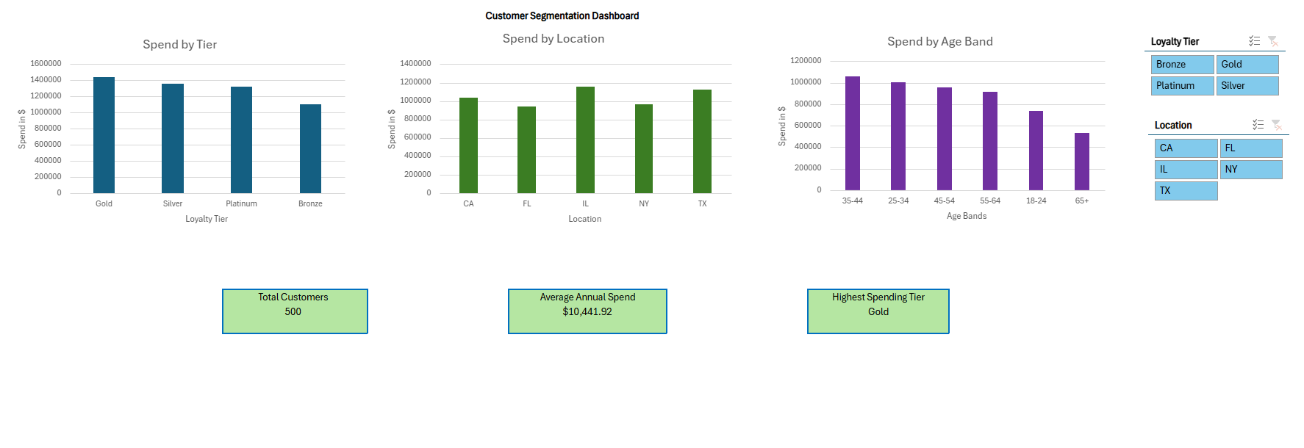

# Key Insights

* Top-performing region: Illinois showed the highest overall spend among all locations.
* Highest-spending tier: Gold customers generated the largest total annual spend.
* Demographic trend: Spending was strongest among customers aged 35–44, suggesting middle-aged segments are the most profitable group.

# Learning Reflection

This project strengthened my ability to build data-driven dashboards in Excel, combining analytical formulas, PivotTables, and visual design to deliver clear, actionable business insights.